**AWS CAPSTONE PROJECT -**

**AWS Setup**

**• Setup VPC for Load Balancer, Application EC2 instance and RDS Database - one public and two private subnets.**

**• Create Load balancer and Auto Scaling Group.**

**• Create RDS DB instance and DynamoDB table.**

**• S3 Bucket**

**• Get domain name and map it with Load Balancer**

**• Create instance profile that has to be attached to the EC2 instances being launched. Instance profile should have**

**permission to access RDS, DynamoDB and S3 bucket.**

**• Lambda function to get triggered when an object is uploaded to the bucket**

**• SNS Topic for Lambda and user email id subscription**

1. Created a VPC , 2 Public Subnet and 1 Private subnet .

vpc

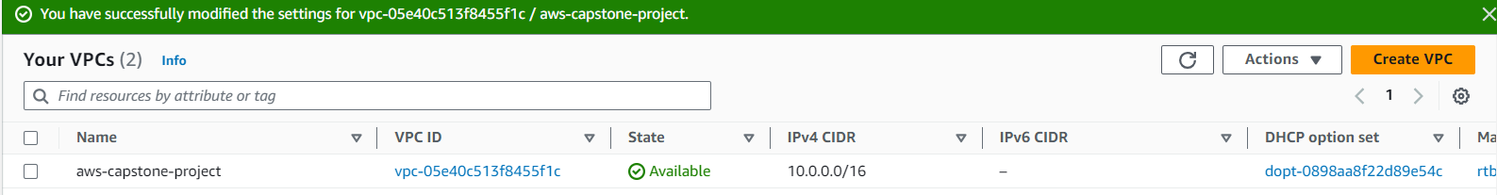

Subnets

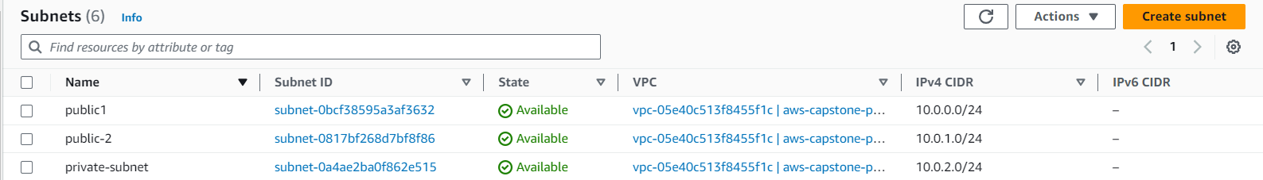

1. Set up firewall in VPC.

Set up internet internet gateway , Nat gateway , security groups .

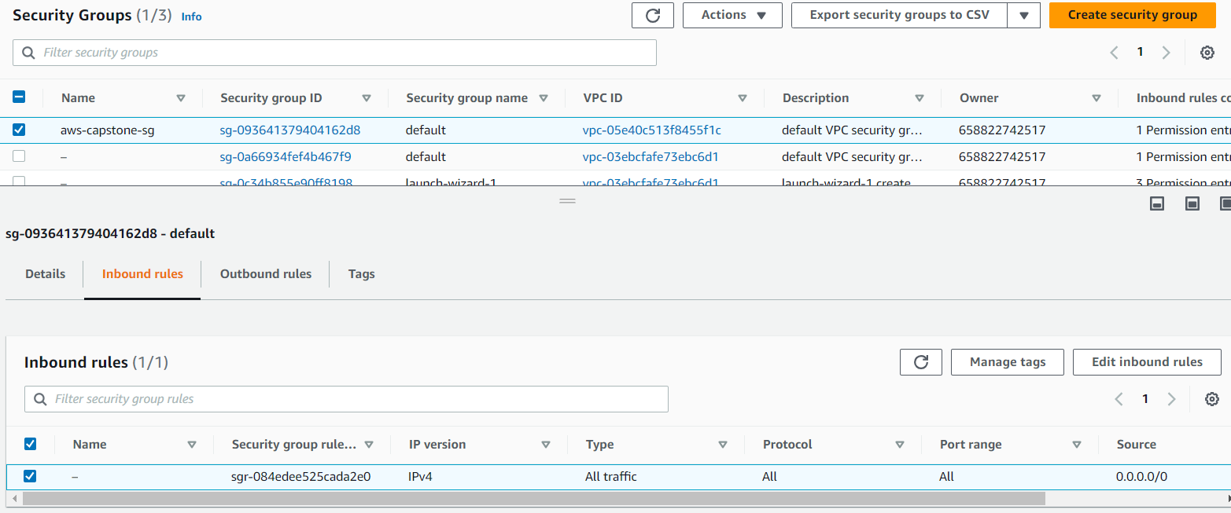

1. Create a Bashtion host , and launched a instance in public subnet.

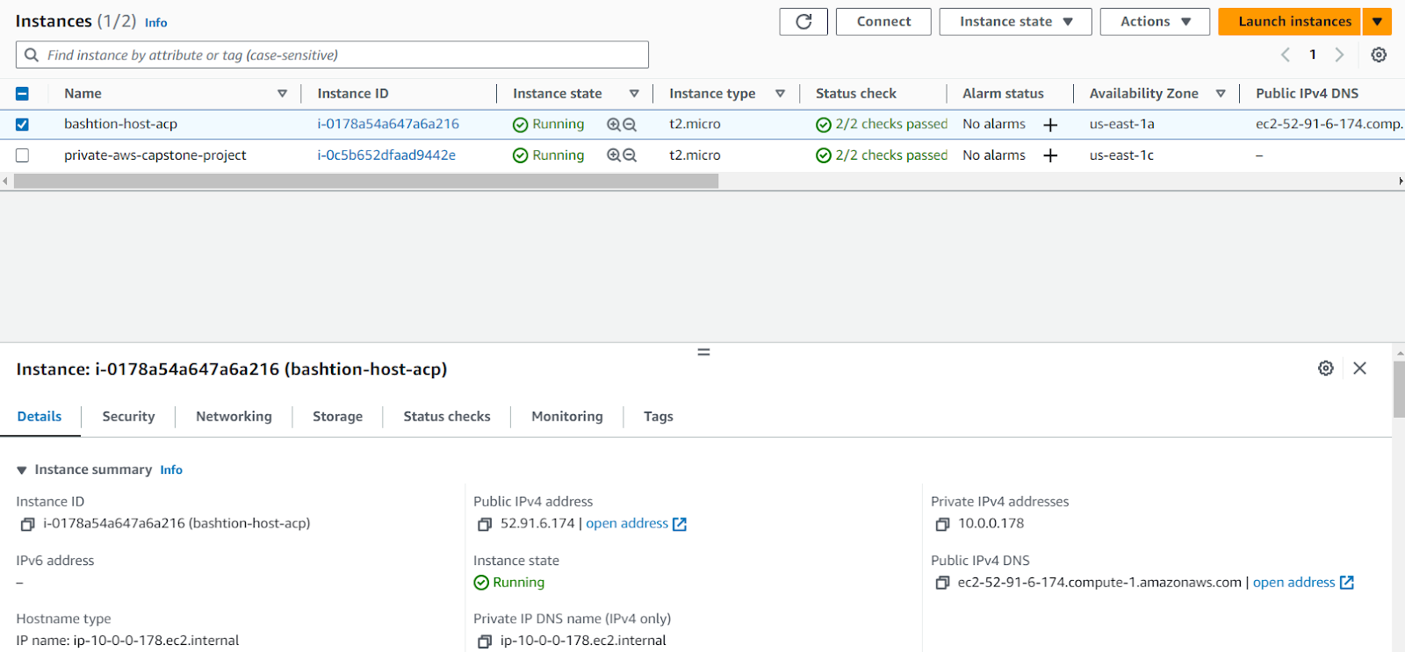

1. Created the S3 Bucket to store images for static website hosting.

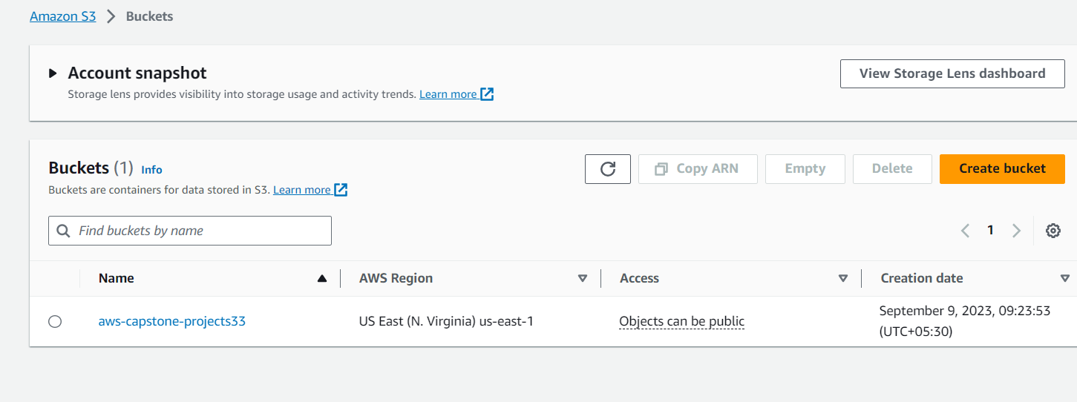

Hosted a static website on s3.

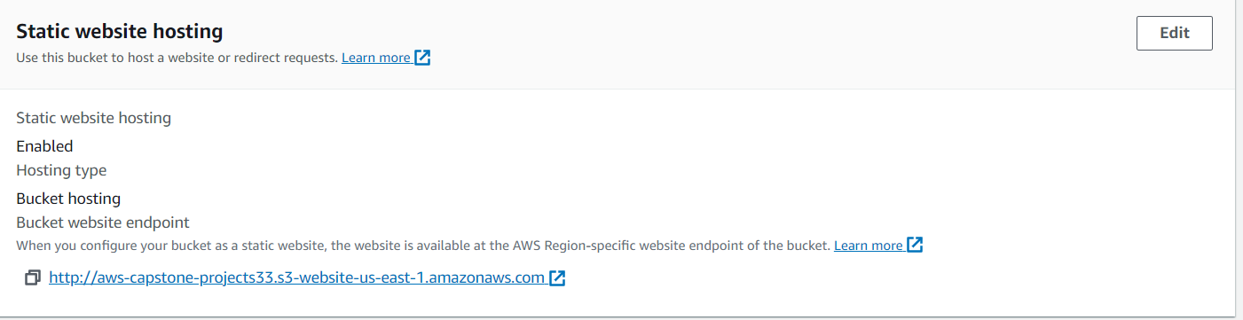

1. Created an RDS instance

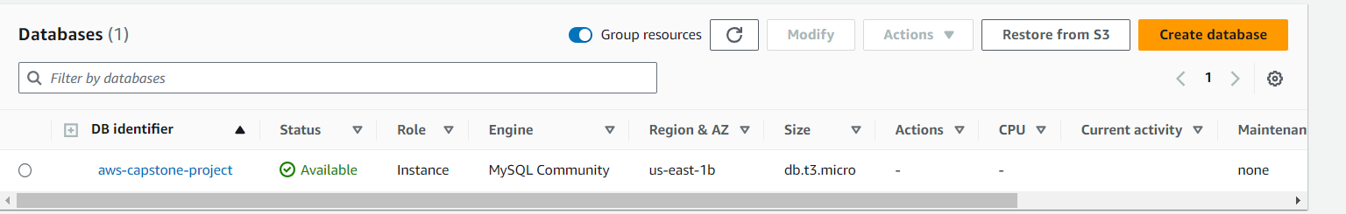

1. Created a Dynamo DB table to store the metadata of image which is to be uploaded.

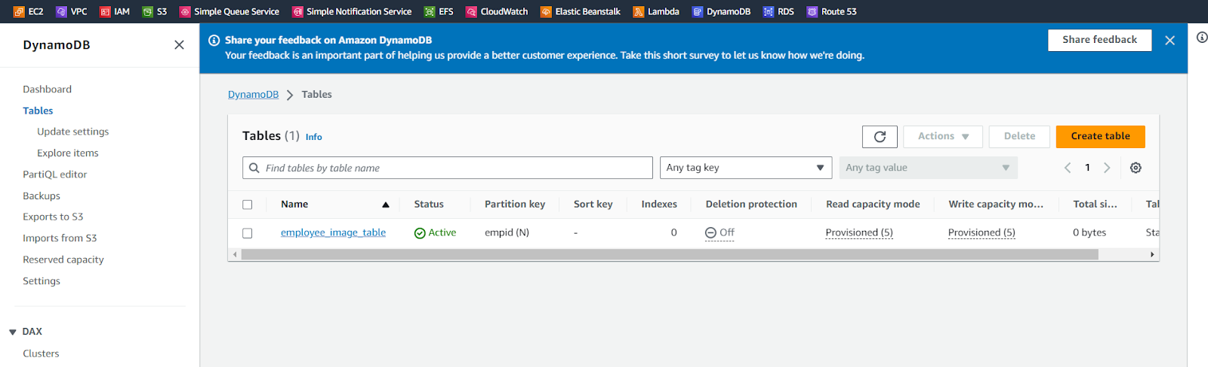

1. Set up a domain name in route 53 , by setting up the name servers in route 53 under hosted zones.

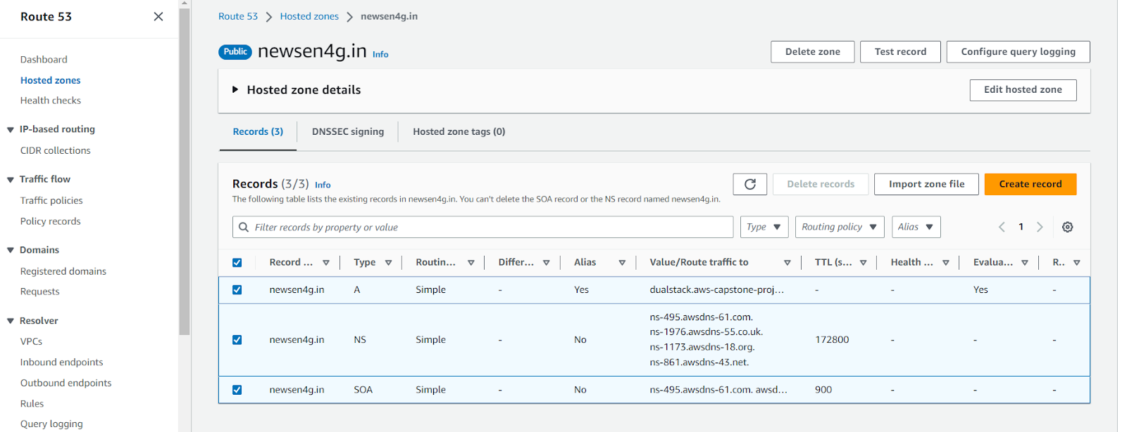

Also set up a record to join the route 53 dns with the load balancer.



1. Logged in to the Application server on private instance using the bastion host , and set up the Python flash application in it , by setting up the database name , username , password and RDS endpoint in it .

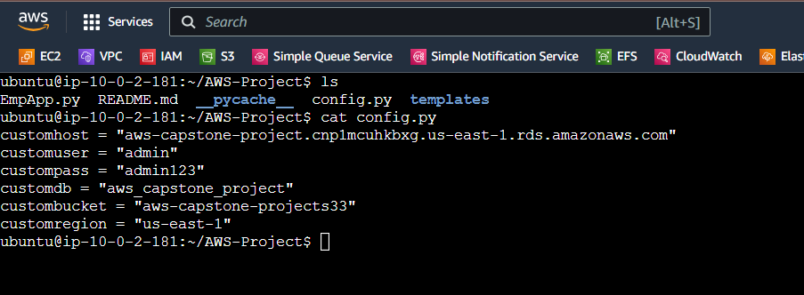

1. Created the Load balancer , and target group to distribute the traffic coming on 2 public subnets towards the private subnet.

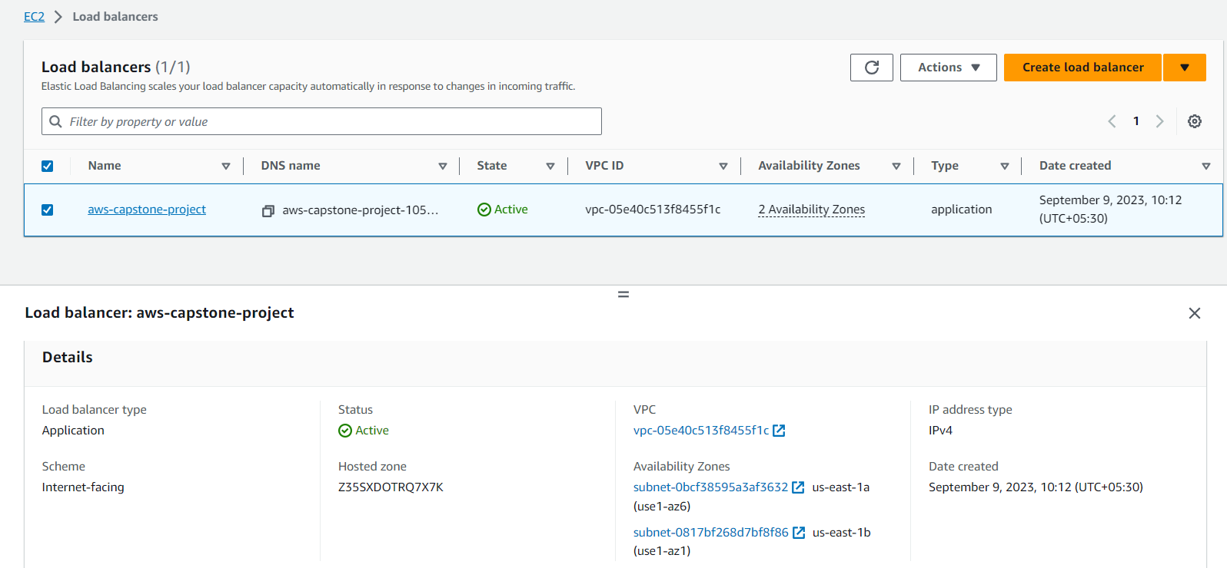

1. CReated the s3 event , to send notification via SNS towards email id, created a topic for this.

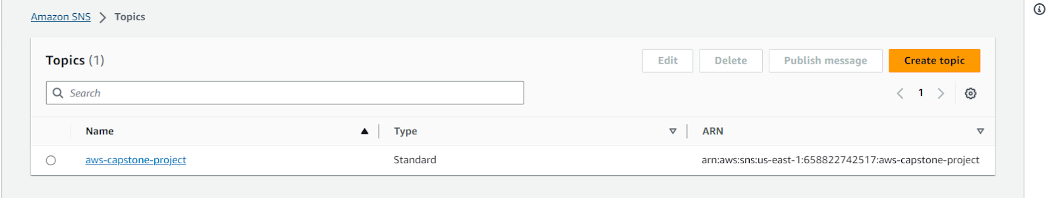

1. Created the subscription , and configured a email on which email to be sent whenever a object get uploaded inside the s3 bucket.

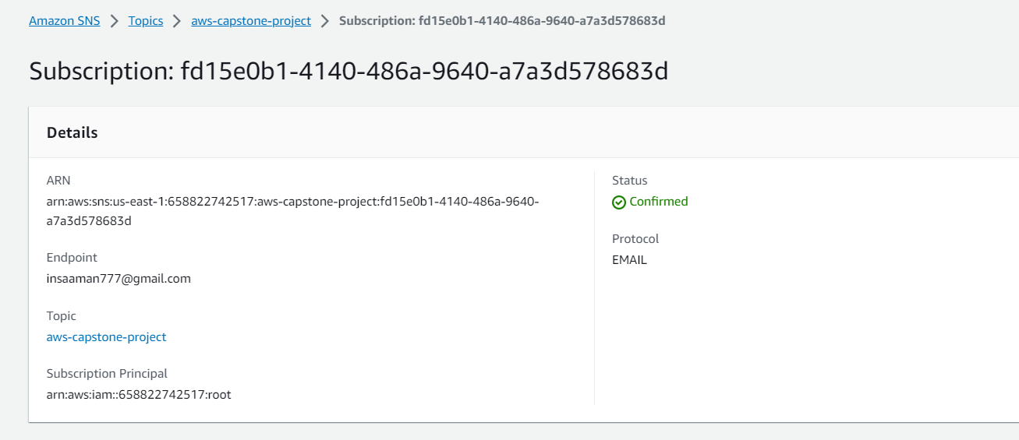

1. Testing the application

